PRIDE

In the previous sections of the tutorial, we identified proteins using curated database sequences and enriched our results with knowledge from external resources. In order to allow the community to benefit from your results in turn, online repositories are available to enable the exchange of data. Moreover, making the data public is now required by most journals prior to publication.

**Proteomics Results**

The proteomics identifications database1 (PRIDE, <http://www.ebi.ac.uk/pride>) and ProteomeXchange (<http://www.proteomexchange.org>) are the repositories of choice for protein identification data. For both of them, the identification results should be converted into the PRIDE XML format. In this section, we will look at how to load a PeptideShaker project into PRIDE and how to visualize PRIDE data using PRIDE Inspector2.

1. Submitting Data to PRIDE

In this section, we will generate a PRIDE XML file from the previously used human platelet dataset. Such a file can be directly uploaded via the PRIDE FTP and made available for the review of a paper for instance. In such cases, access codes to be included in the manuscript are provided by PRIDE for the reviewers. Once the manuscript is accepted, the data is made publicly available.

Load the project human.cps located in the resources folder into PeptideShaker:

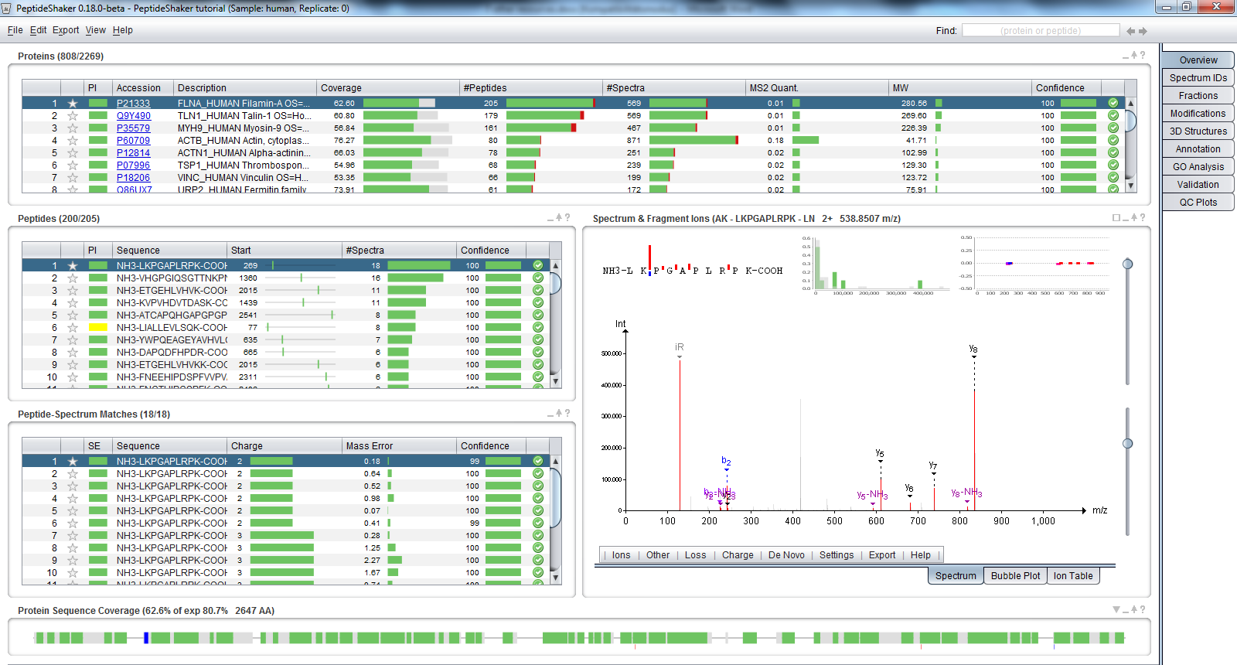

Now go to the ‘Export’ menu at the top and select ‘PRIDE XML’. The following dialog appears:

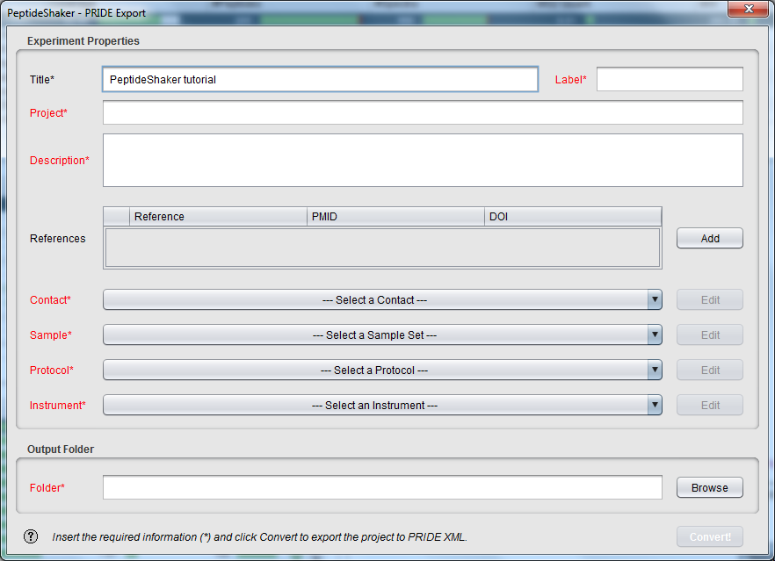

The information needed here will be used to reference your dataset in PRIDE. Using the respective fields, create a contact, a sample, a protocol and an instrument for our dataset. Note that all terms are standardized, creating a Human Platelet Sample as detailed below will thus help other platelet interested scientist to find your results straightforwardly.

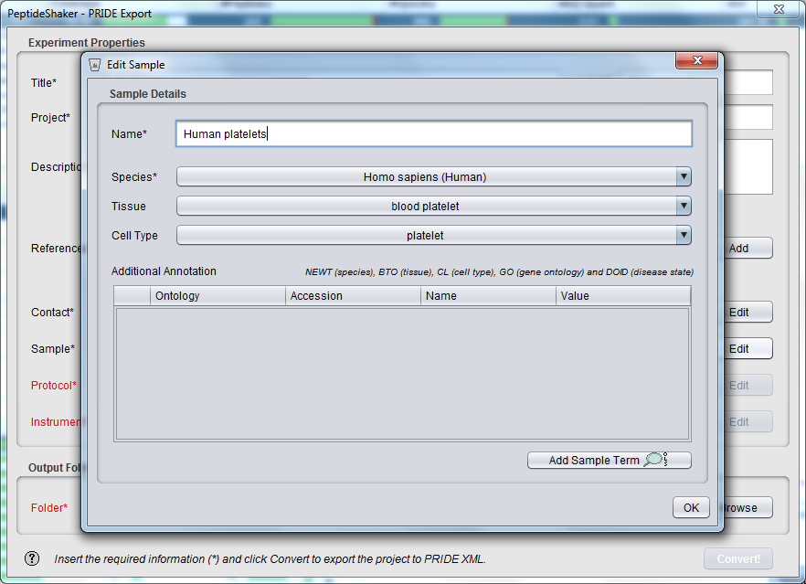

Selecting an output folder and clicking on the 'Convert!' button will start the creation of the PRIDE XML file. In order to save time, the corresponding file has already generated for you and is located in the resources folder.

We will get back to this file in a minute, but first will take a quick look at PRIDE.

1. Browse PRIDE

Go on the PRIDE website (<http://www.ebi.ac.uk/pride>) and search PRIDE project number 1, you should see the following screen:

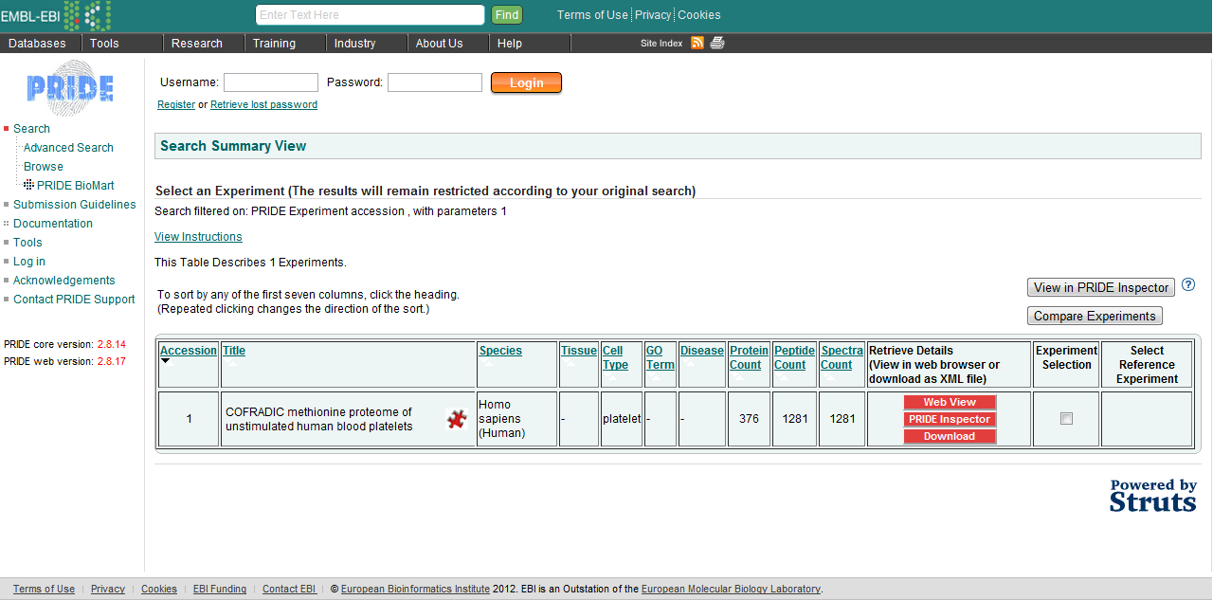

Click on ‘Web View’ to browse this project. *What information can you access on this experiment? What is your opinion about making all data available?*

It is possible to browse all online PRIDE datasets using PRIDE Inspector (<http://pride-toolsuite.googlecode.com>), available in the resources folder. Starting PRIDE Inspector, you should see the following:

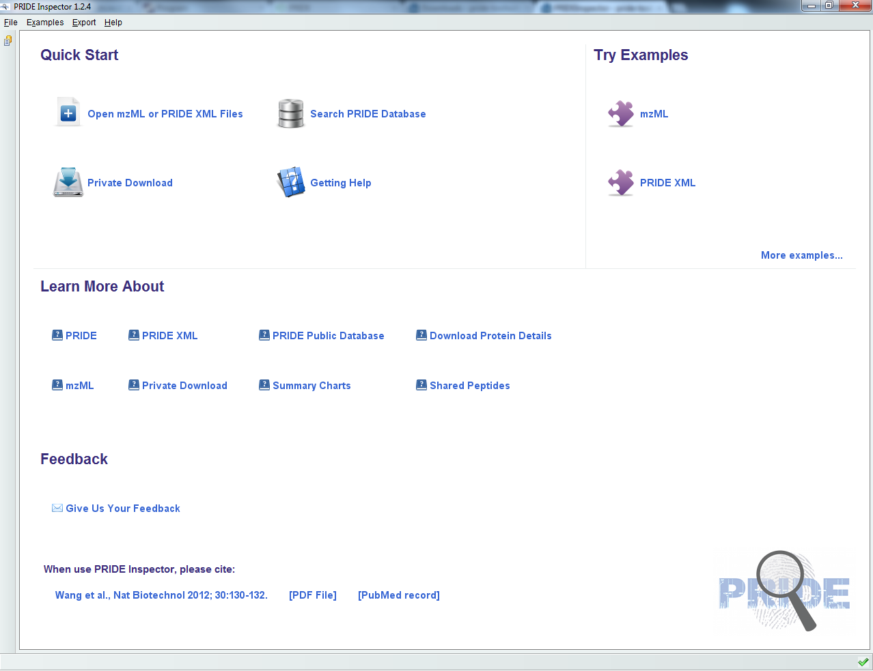

Select ‘Open mzML or PRIDE XML Files’ and open workshop_example.xml located in the resources folder. You should see the following:

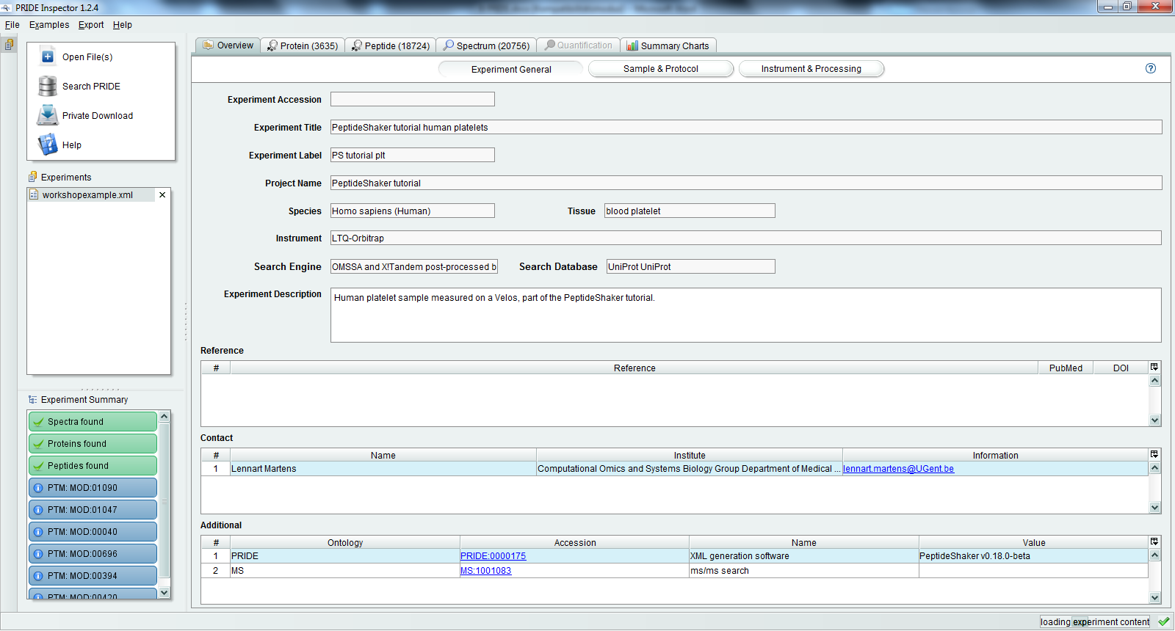

Note that all spectrum annotation (modifications, ions, etc.) have been passed by PeptideShaker to PRIDE Inspector as standardized terms and will thus be available for all other online resources. *What difference do you see compared to the PeptideShaker results?*

References

(1) Martens, L.; Hermjakob, H.; Jones, P.; Adamski, M.; Taylor, C.; States, D.; Gevaert, K.; Vandekerckhove, J.; Apweiler, R. PRIDE: the proteomics identifications database. *Proteomics* **2005**, *5*, 3537.

(2) Wang, R.; Fabregat, A.; Rios, D.; Ovelleiro, D.; Foster, J. M.; Cote, R. G.; Griss, J.; Csordas, A.; Perez-Riverol, Y.; Reisinger, F.; Hermjakob, H.; Martens, L.; Vizcaino, J. A. PRIDE Inspector: a tool to visualize and validate MS proteomics data. *Nat Biotechnol* **2012**, *30*, 135.